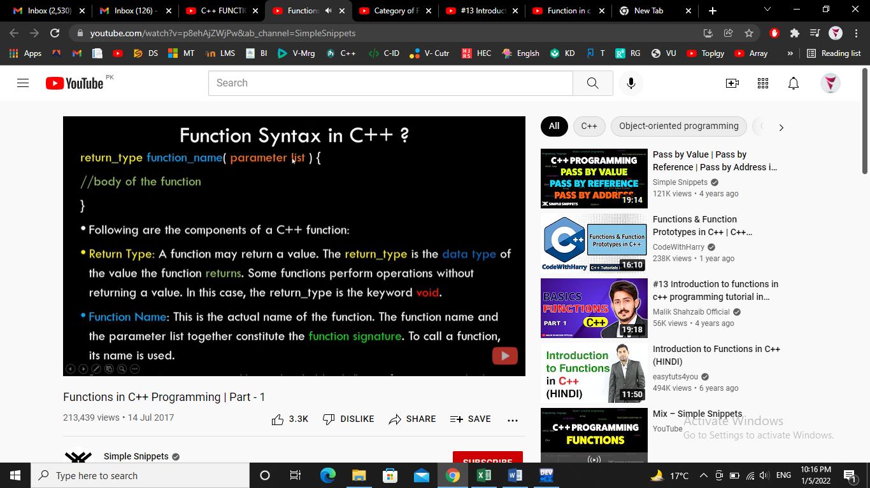
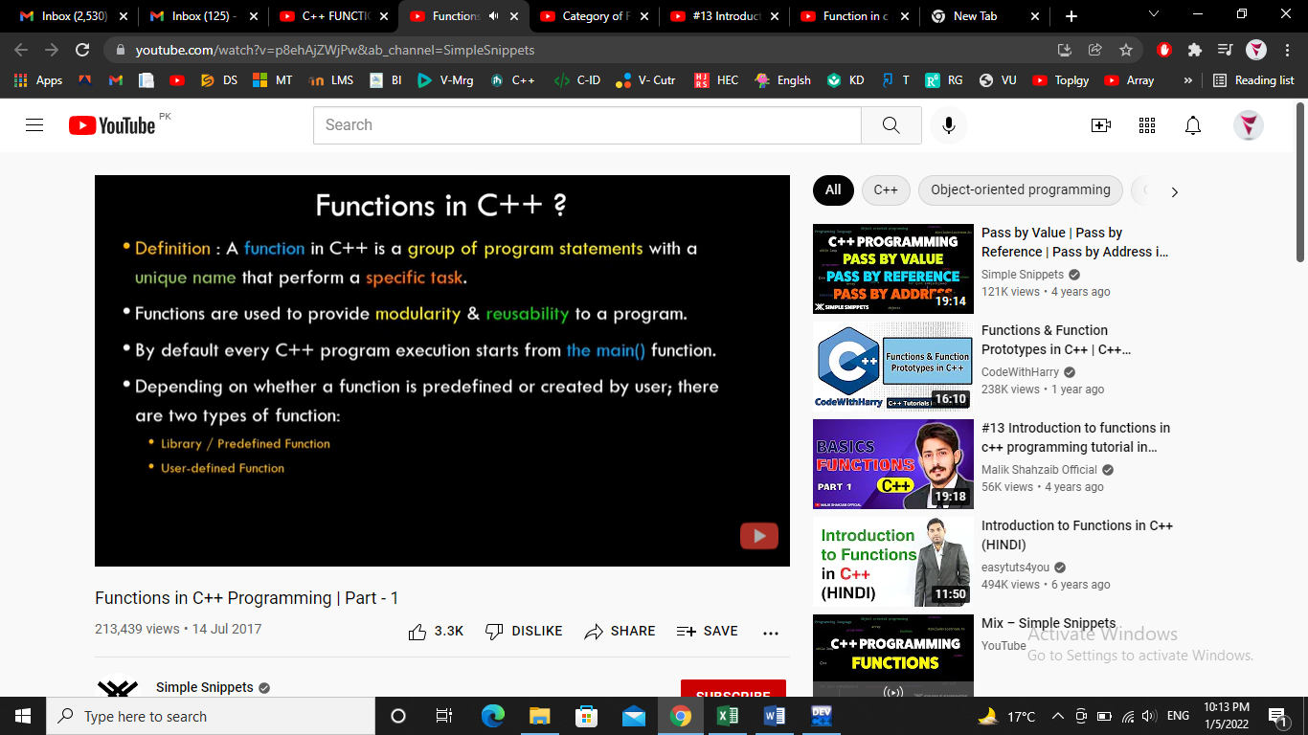

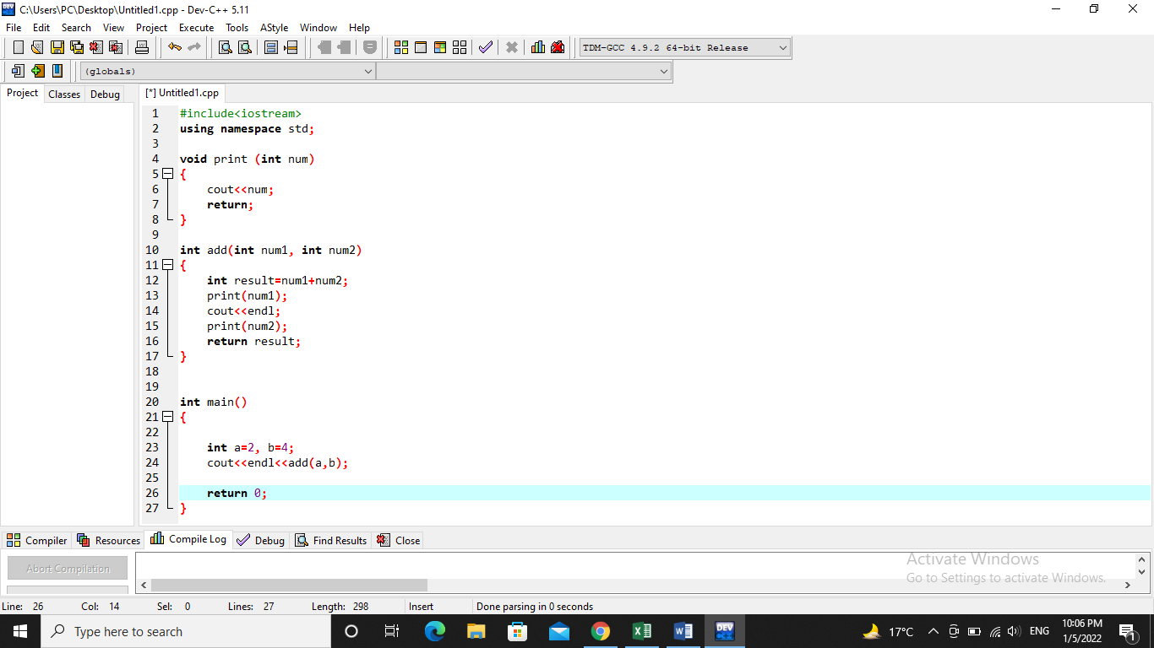

- Functions without arguments and without return values.
- Functions without arguments and with return values.
- Functions with arguments and without return values
- Functions with arguments and with return values.
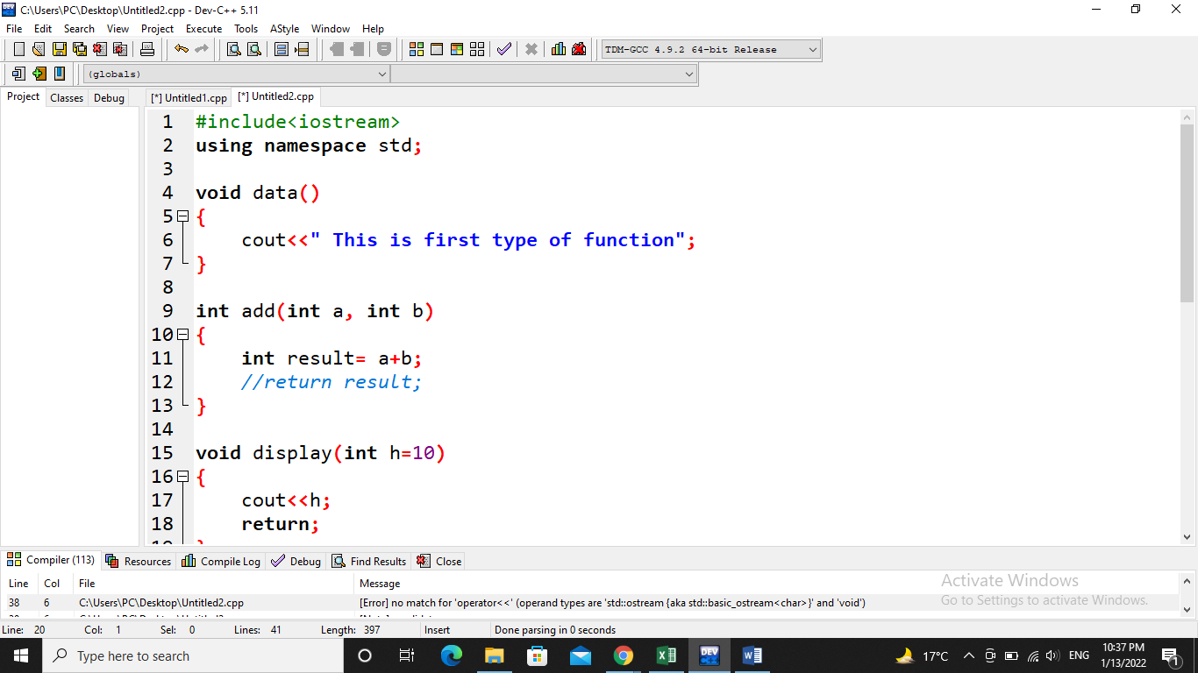

Functions without arguments and without return values.

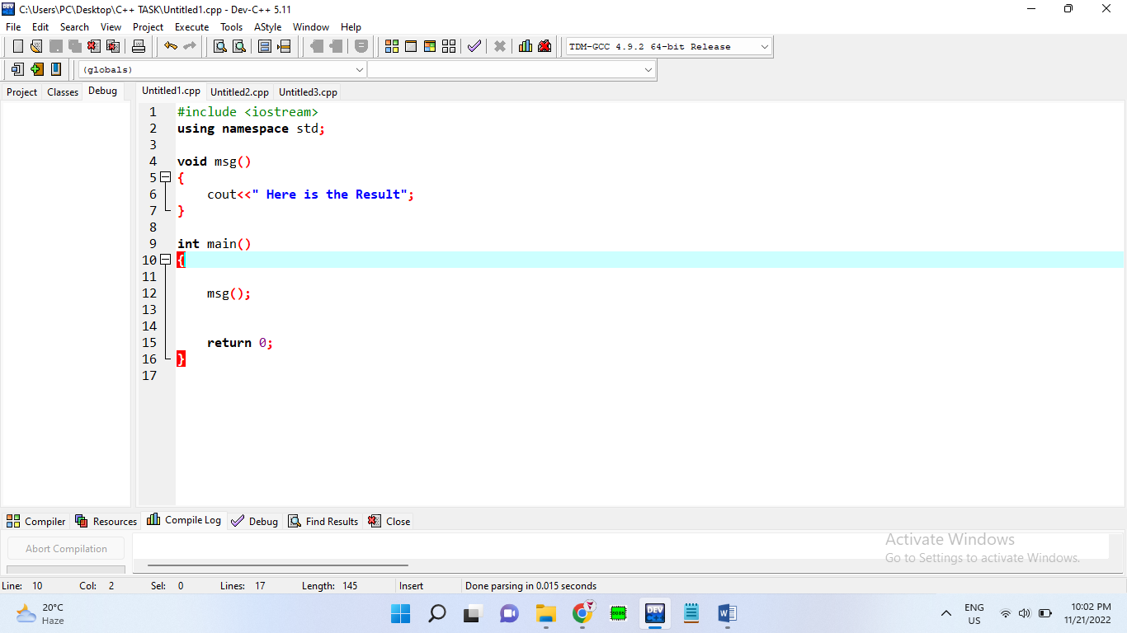

Functions with arguments and without return values Functions with arguments and with return values.
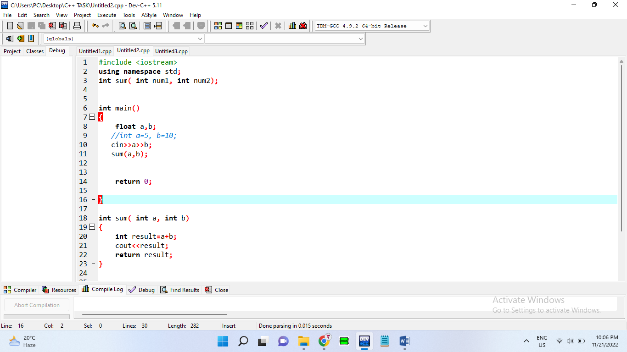
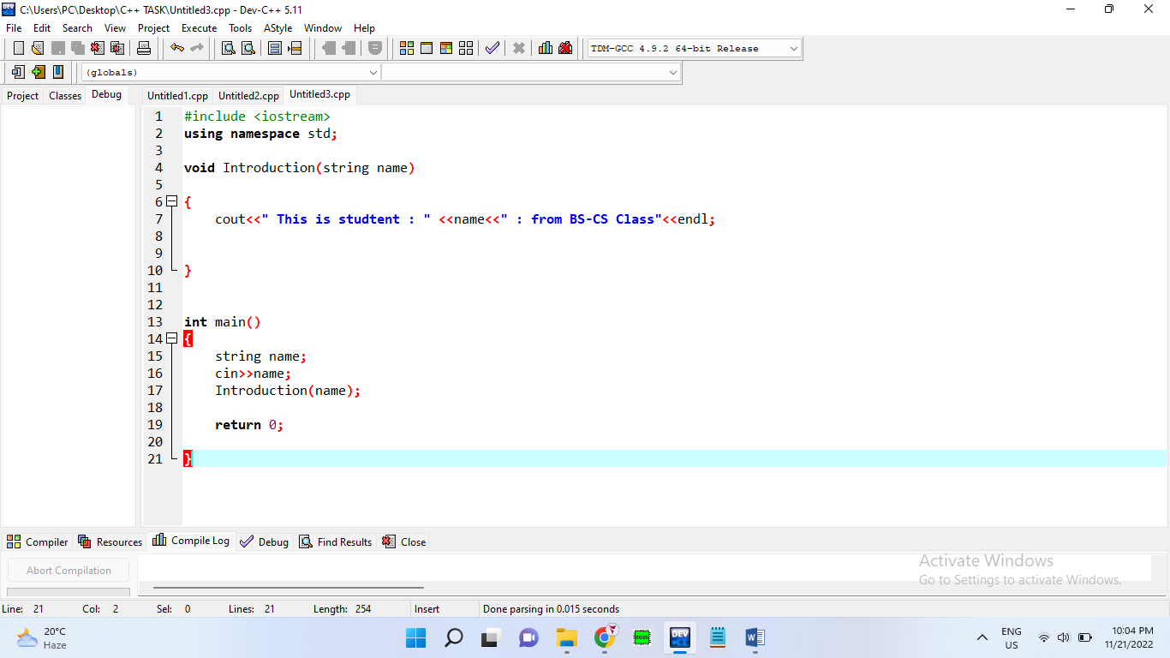

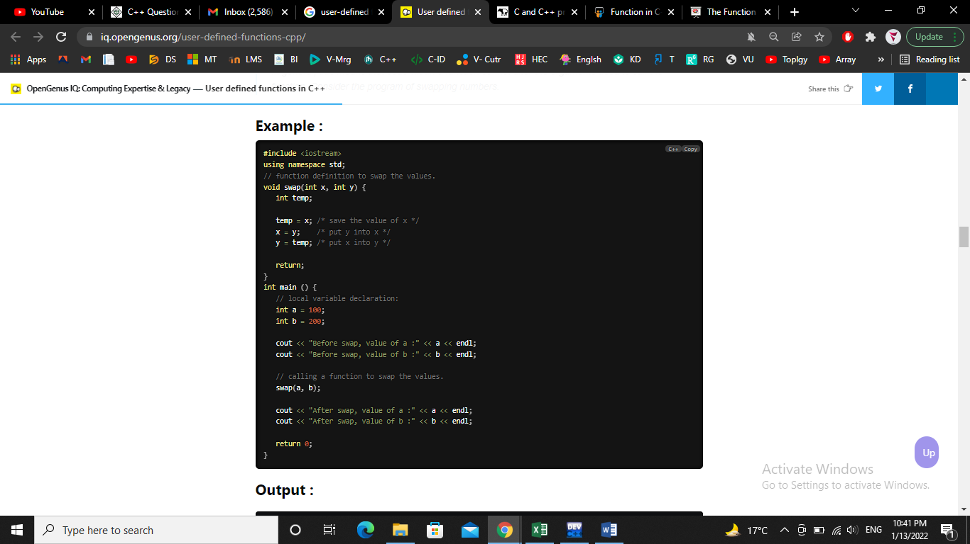
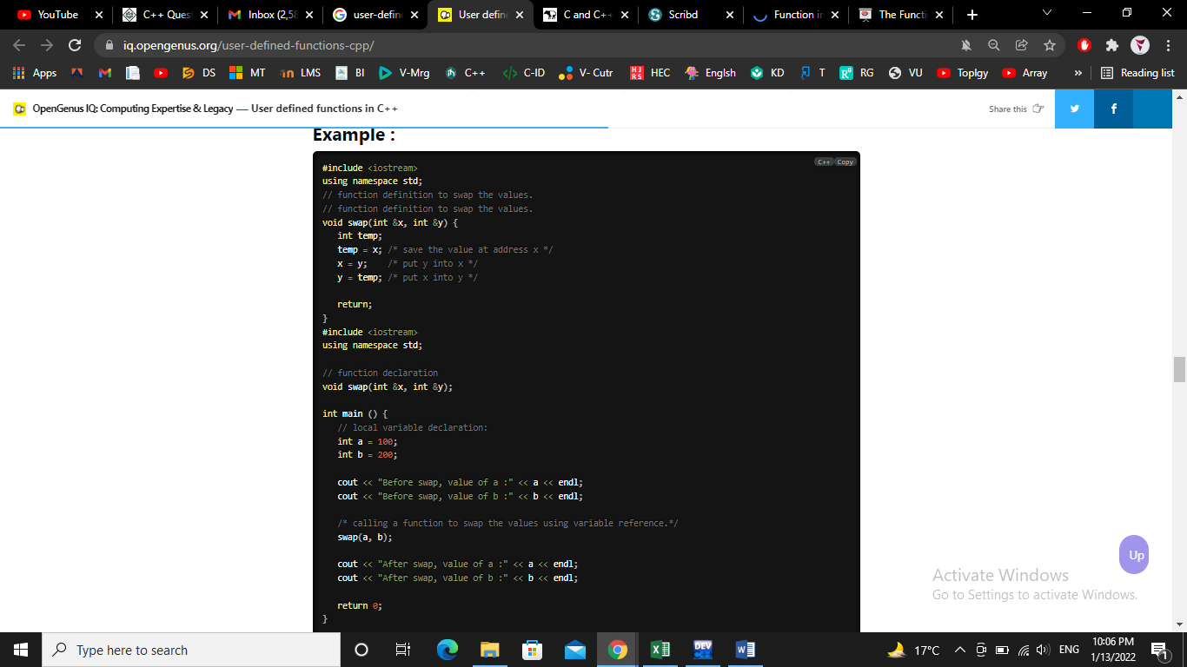
The para meters that are defined in the function definition are called Formal Parameters. The parameters in the function call which are the actual values are called Actual Parameters
Figure 1-CALL BY VALUE FUNCTION
Figure 2-CALL BY REFRENCE FUNCTION

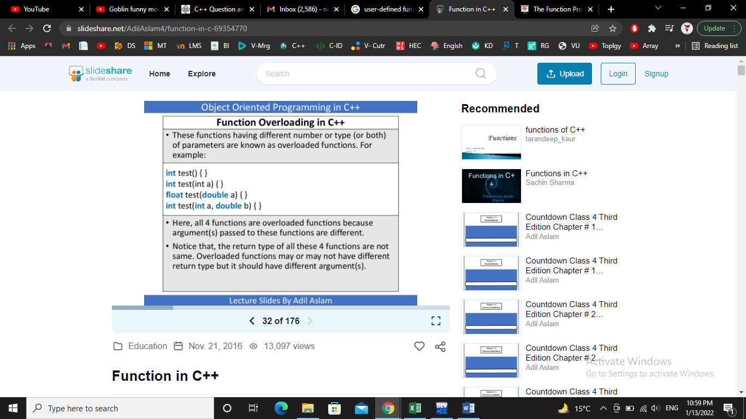
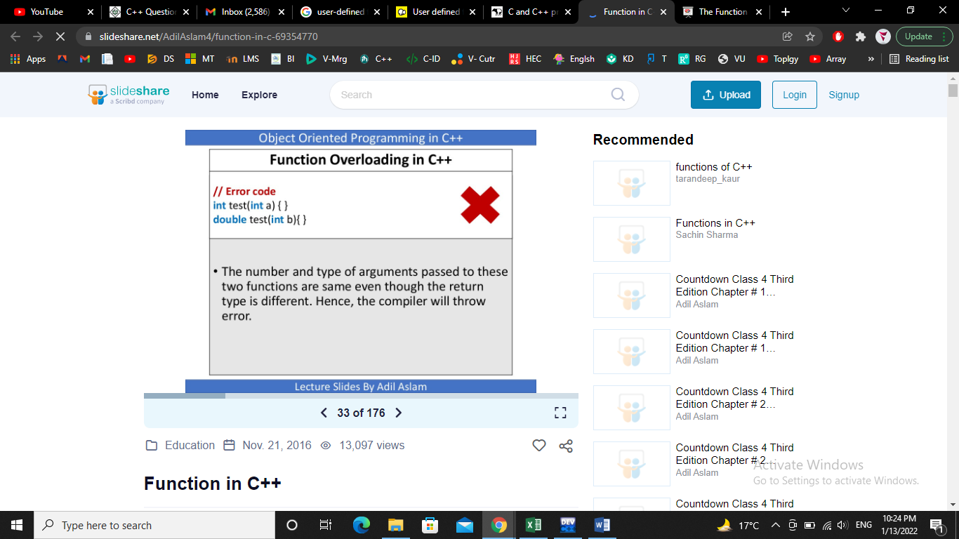
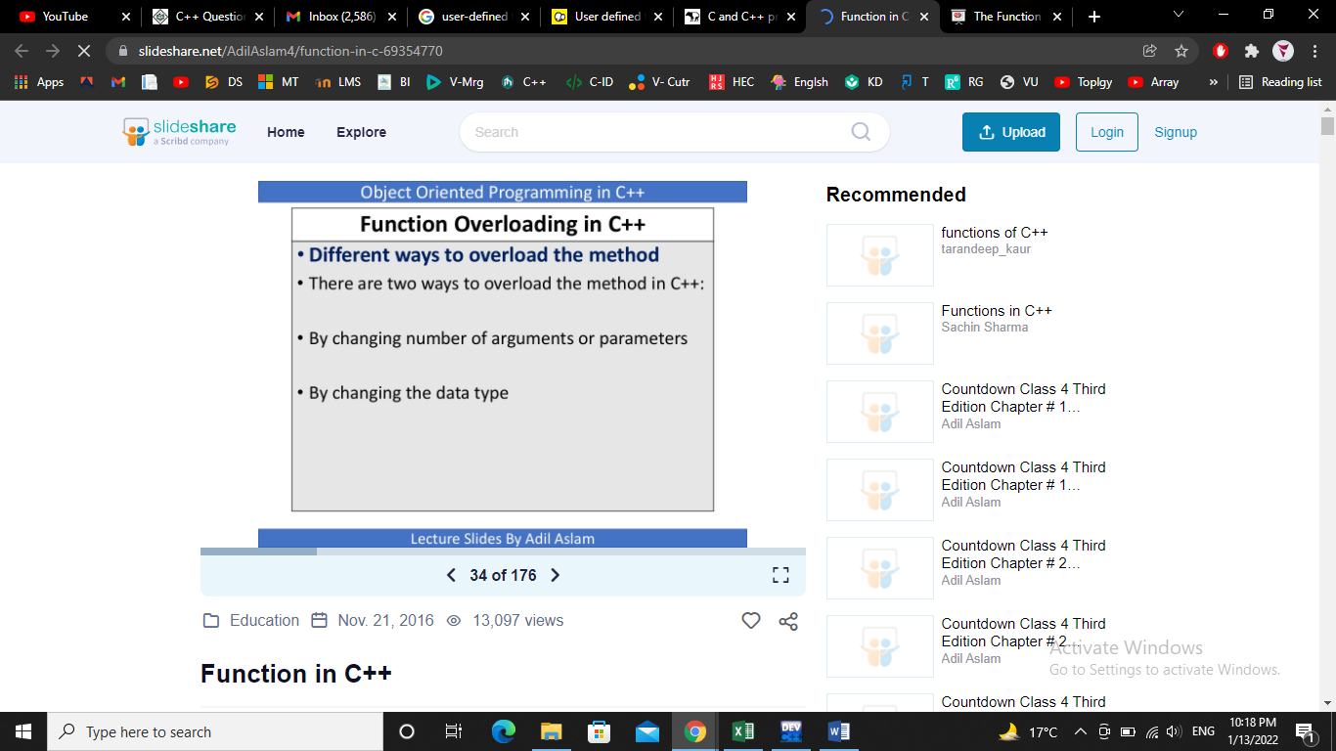

Sr. | String Name | Description
 | strcpy(s1, s2); | Copies string s2 into string s1.
 | strchr(s1, ch); | Returns a pointer to the first occurrence of character ch in st ring s1.
 | strcmp(s1, s2); | Returns 0 if s1 and s2 are the same; less than 0 if s1<s2; greater than 0 if s1>s2.
 | strcat(s1, s2); | Concatenates string s2 onto the end of string s1.
 | strlen(s1); | Returns the length of string s1.

